3.1 I select and use appropriate testing methods to check that all the elements in my website work as planned

After using <https://validator.w3.org/> to check my code I ran my website using two different browsers to check if the website worked as planned in multiple browsers. The below screenshots show how the website looks on Google Chrome and Internet Explorer;

**Chrome**

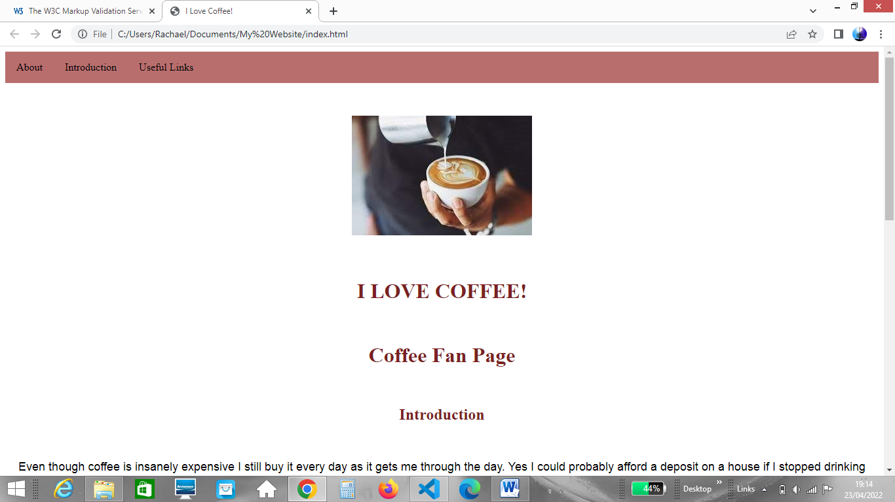

**Internet Explorer**

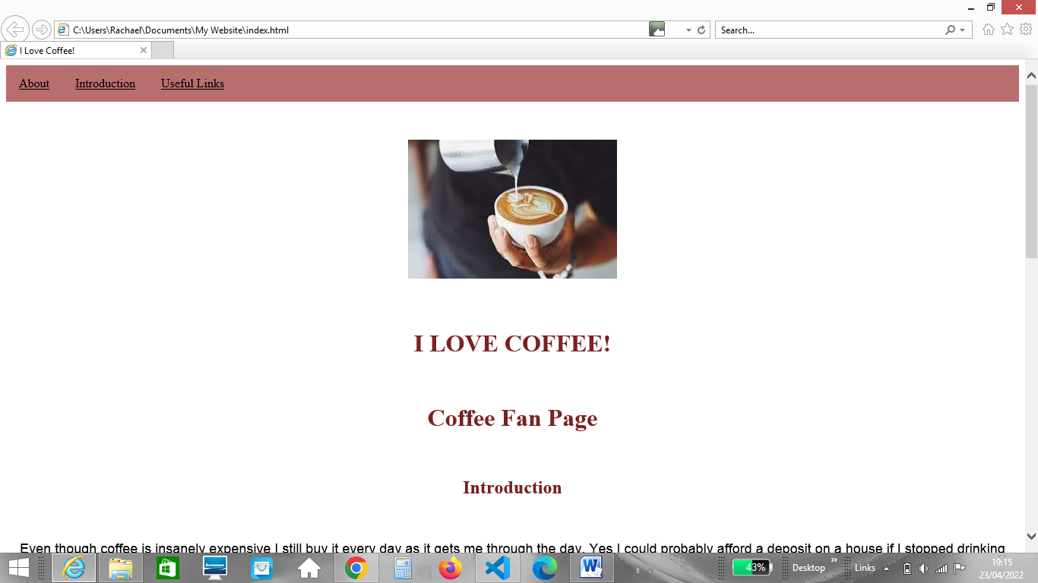

Once I had finished my website I asked my friends for feedback regarding the look and structure of the website and if they felt any improvements could be made so I could make further improvements.